Creating Sales Orders in Praxis
Outline of process:
- Verify price matches what was quoted.
- Discuss price with manager if quote is older than 30 days.
- Save Purchase Order and email chain to the sales folder.
- Mark the building as sold in Praxis.
- Fill out the Building Order Sheet and Sales Release in Praxis.
- Fill out the building handoff documents which include the Project Coordinator Handoff Document, Long Lead Form, and Color Selection Sheet.
- Send the Project Coordinator Handoff Document to the Project Coordinator.

- When we receive a PO, start by verifying that the price on the PO matches what we have in Praxis. If this PO is sent via DocuSign or another document signing service, ask the sender to make the Sales Manager the signer if you are not the Manager. More commonly, you’ll see a PO email like the one below:
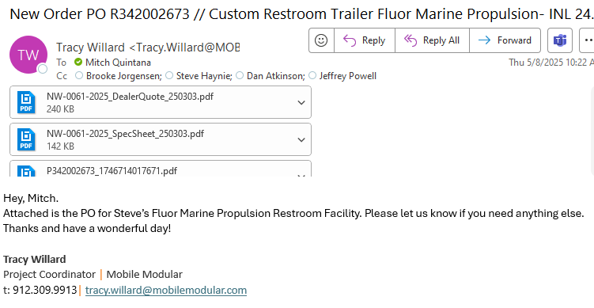
- Open the PO and compare the PO price and version numbers in Praxis match the PO. In the image below the base price matches. The customer supplied the quote with the PO to verify version number. Remember that any change gets rounded to the nearest whole dollar on the quote in Praxis when printed.
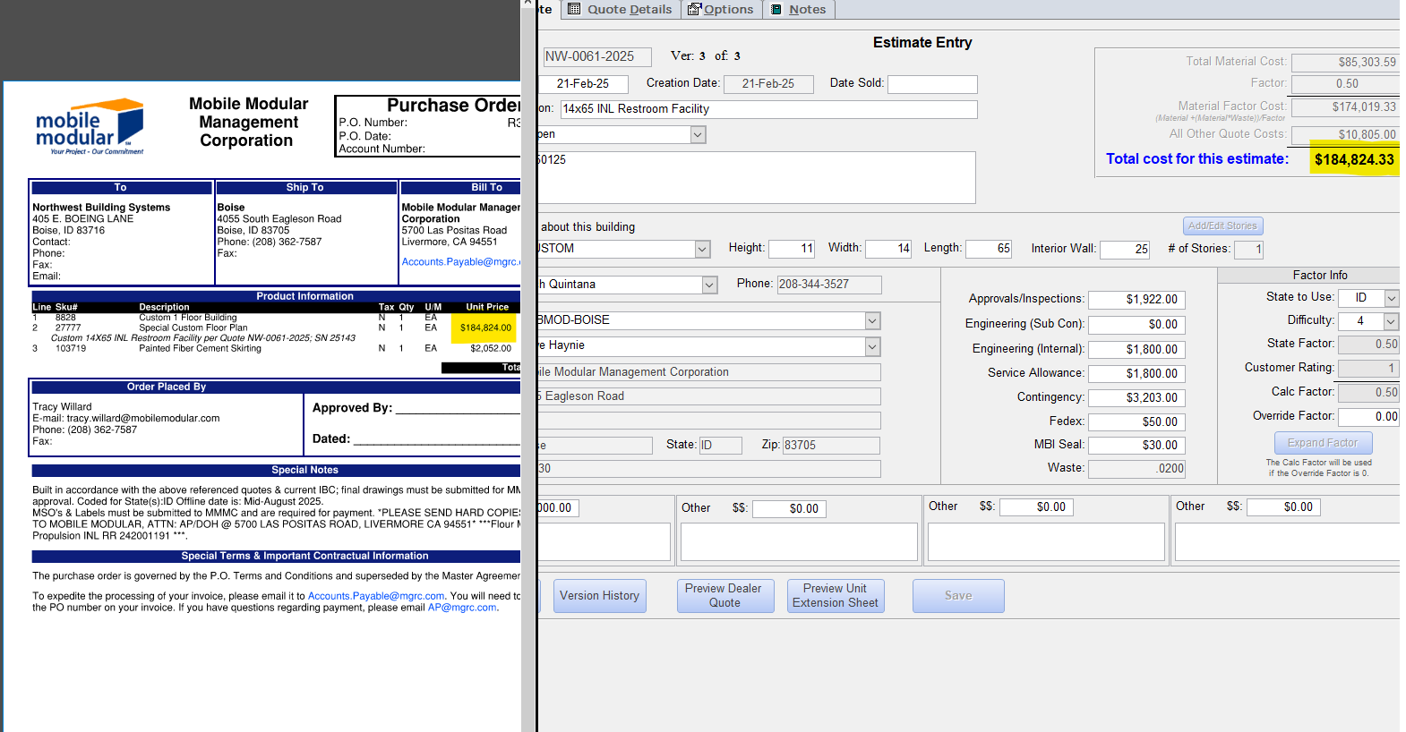
- If options were taken, verify the option price is also correct. Options also are rounded to the nearest whole dollar so the option below rounds to $2,052 on the quote.
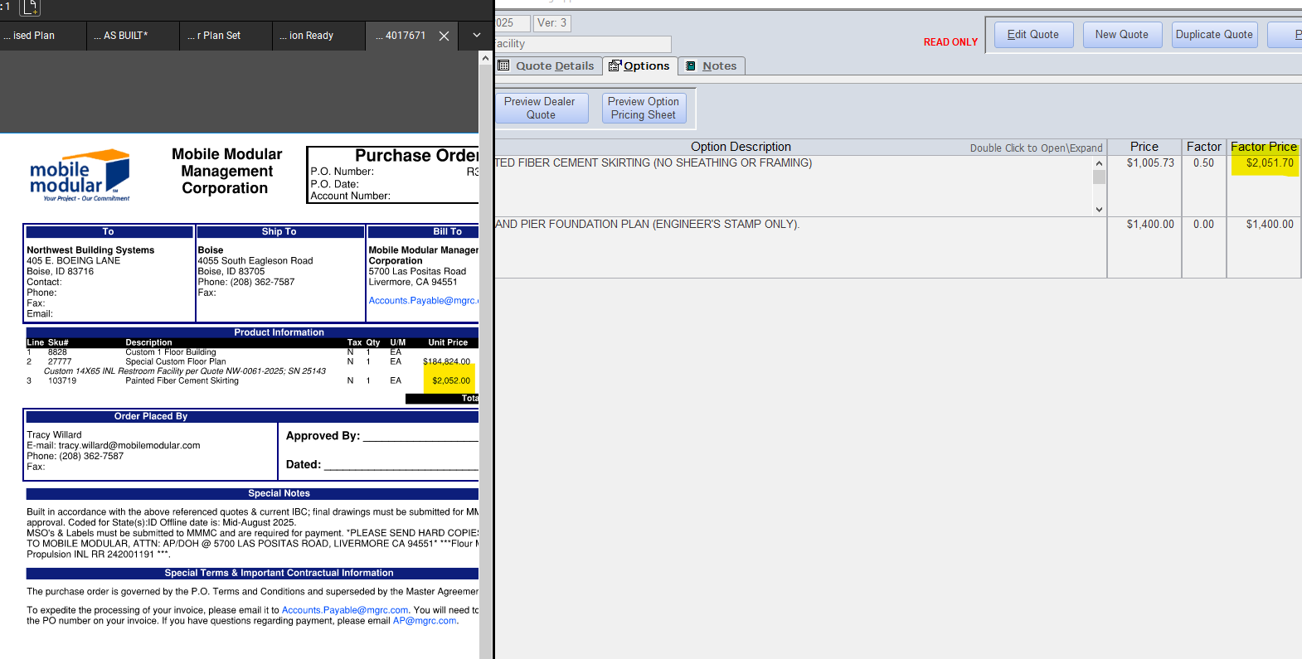
- WHEN NUMBERS ARE VERIFIED AND YOU ARE READY TO CONVERT TO A SALE, ASK THE REST OF THE SALES TEAM IF THEY ARE TRYING TO ADD A PO AT THIS TIME. ONLY ONE PERSON SHOULD BE CREATING A PO AT A TIME TO BE SURE BUILDING NUMBERS LINE UP PROPERLY.
- Go to the quote folder your bid documents are saved in. Your quote folder number should be in the quote notes in Praxis.
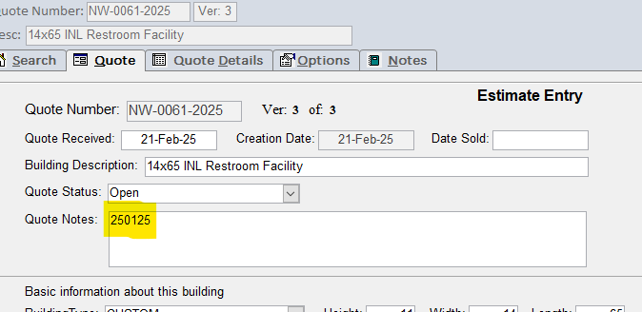

- Add the PO to the purchase order folder.
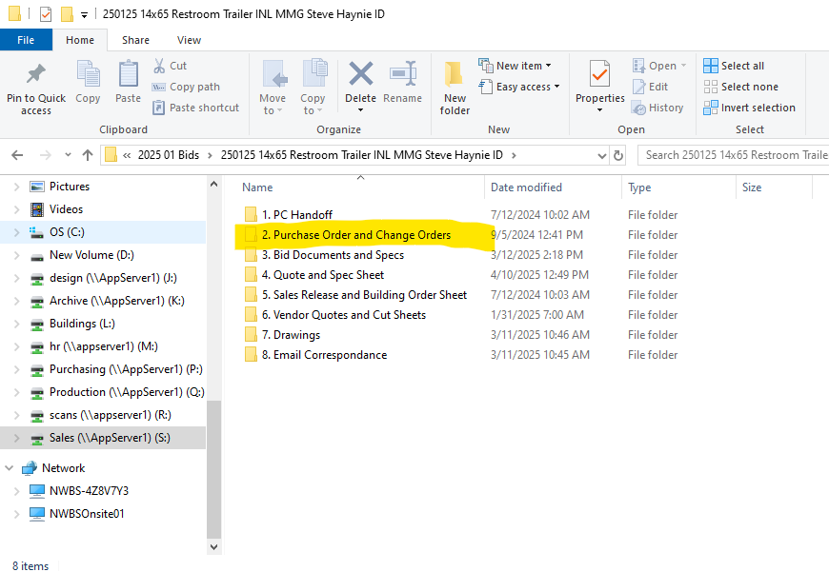
- Update the Email Correspondence folder with any email communication or additional details not already stored (including the email chain the PO is on).
- Add any building specific cut sheets in the Vendor Quotes and Cut folder.
- You are ready to process the PO in Praxis. Double check that the PO, and quote numbers match before proceeding!

- Back in Praxis, Move the quote status to sold then add the date sold.
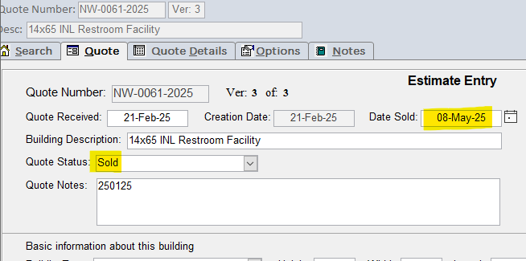

- Press Save.
- Add how many buildings (**NOTE WE ARE TALKING BUILDINGS AND NOT MODS**) are being sold and be sure the number of serial numbers matches the number of buildings. For NWBS, number of buildings and number of serial numbers will always be the same. Number of mods doesn’t matter here. Press the generate serial numbers button when entered.
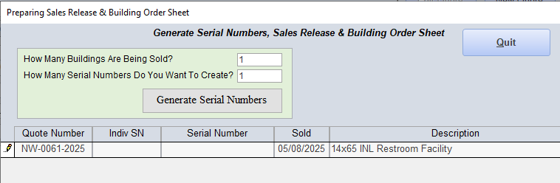
- Press Yes when asked if you’d like to proceed with generating a serial number.

- Make sure the serial number matches what is expected. In the image below, 25238 is the last building number filed and the serial number given to us is 25239 which is to be expected.
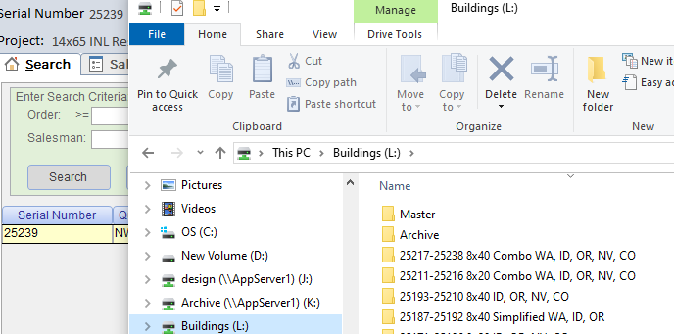
- Choose to view the Sales Release/Building Order sheets.
- Go to the Options tab and select any options that were on the PO. Decline any options that weren’t picked up.
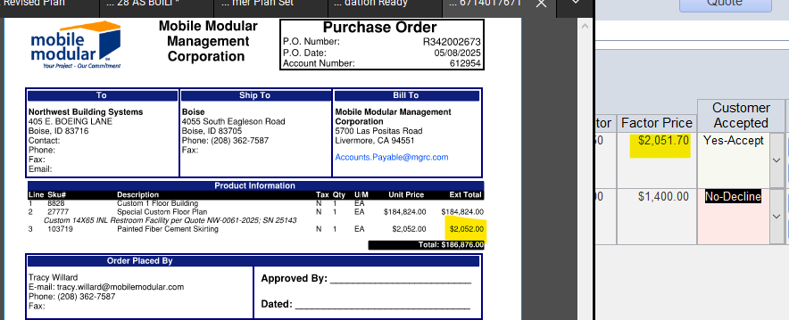

- Go to the building order sheet and click Save.
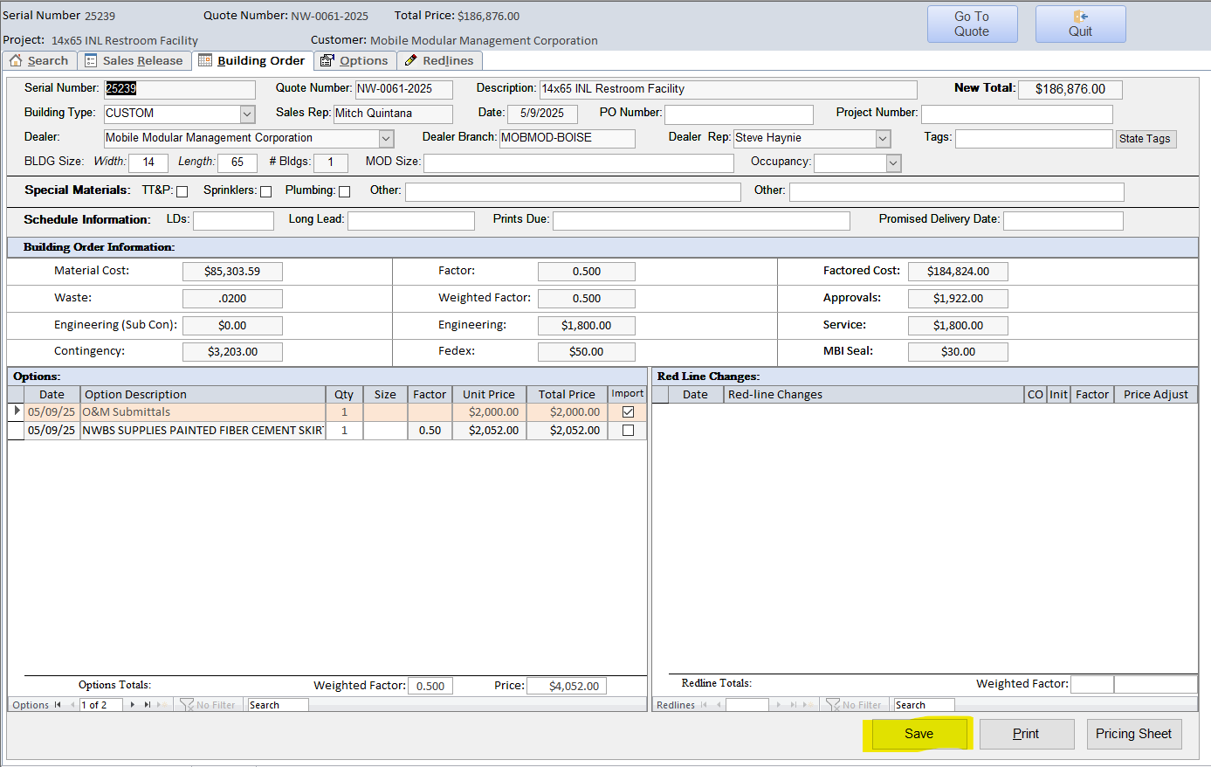
- Verify that the New Total matches the PO total.
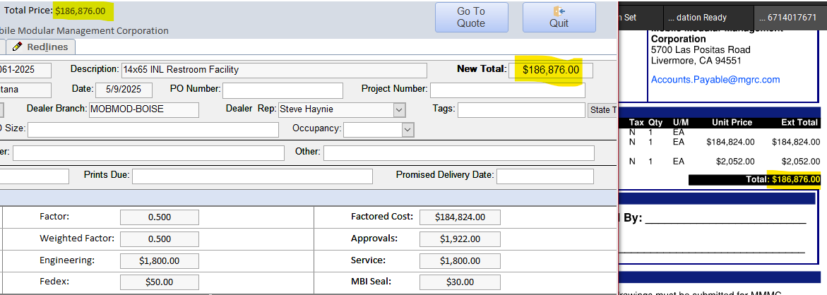

- In the the Building Order Sheet. Add the following to the page:
- Dealer’s PO number.
- State tag(s)
    - Use CTRL+Select to pick multiple states
- Special Materials
- Mod Size
- Occupancy
- Promised delivery date.
- Note the longest lead time item’s lead time to help purchasing.
    - Also note in the email you send the team.
- Note special materials needed.
    - TT&P
    - Sprinklers
    - Plumbing
    - Others
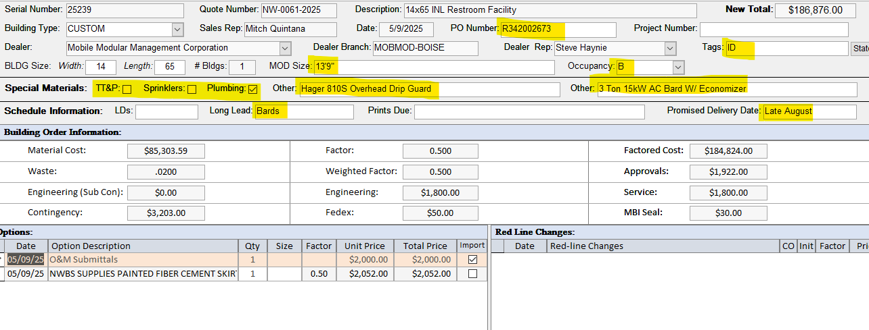

- When finished, print the Building Order Sheet and save it to the bid folder in sales.
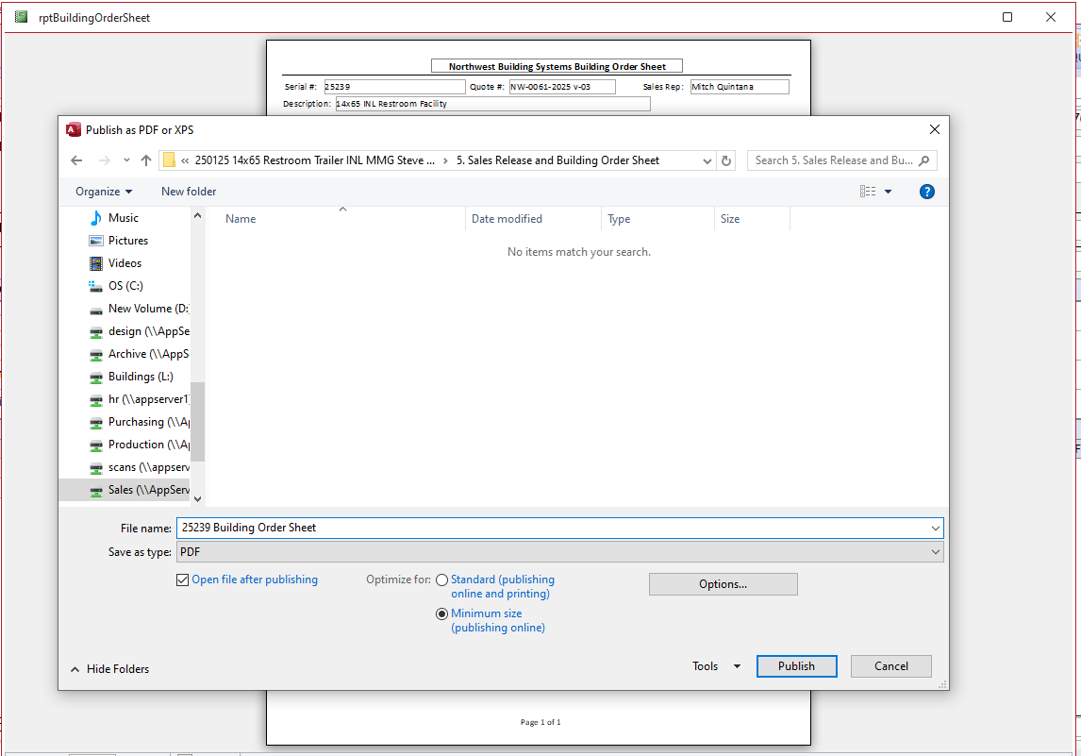

- Now move to the sales release and add as much info as possible to the sales release including:
  - Site address.
  - Climate zone.
  - Floor load.
  - Occupancy.
  - Foundation plan (if applicable).
  - Sprinklers (if so, are we footing the bill?)
  - WUI compliance needed?
  - HVAC & hitch side noted?
  - Vendor cut sheets?
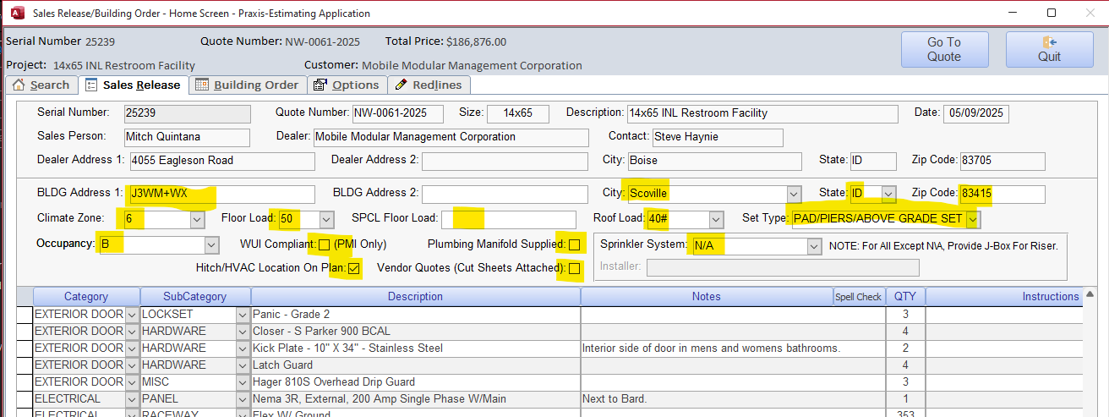
- Add any material changes due to options to the Sales Release now as well. For instance, if we optioned a class A roof, I would add densdeck or change the roof covering in the Sales Release to state class A. For the example below, I am going to note 36” skirting in the Sales Release.
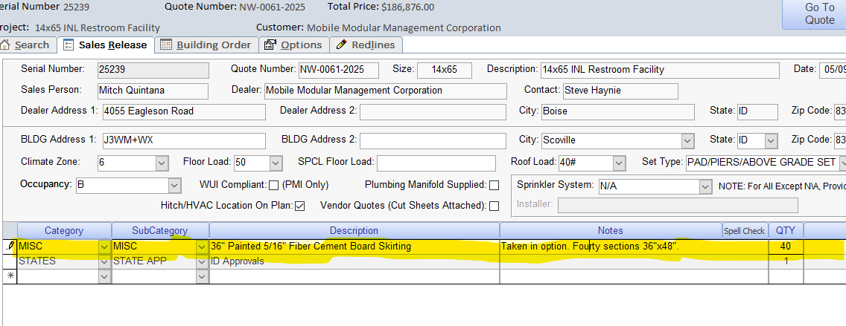

- Save the Sales Release and print it to the bid folder in sales.
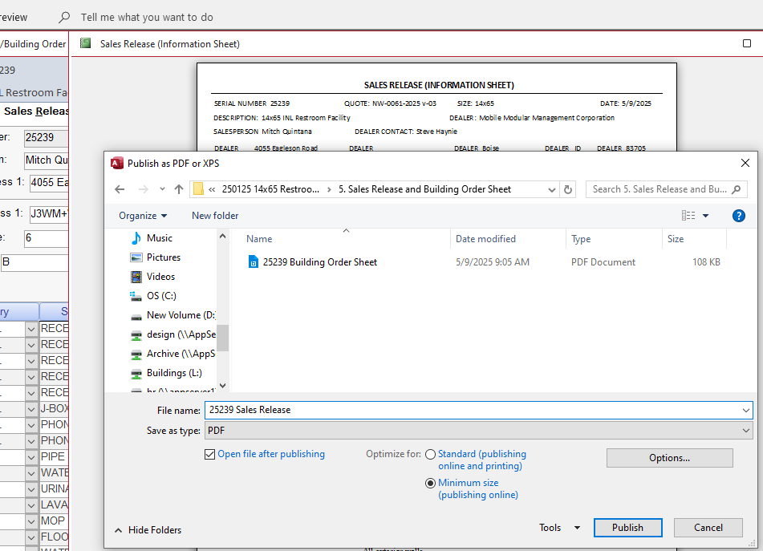
- Once done with the Sales Release and Building Order Sheet, find the Building Handoff Documents folder in the Sales Drive.
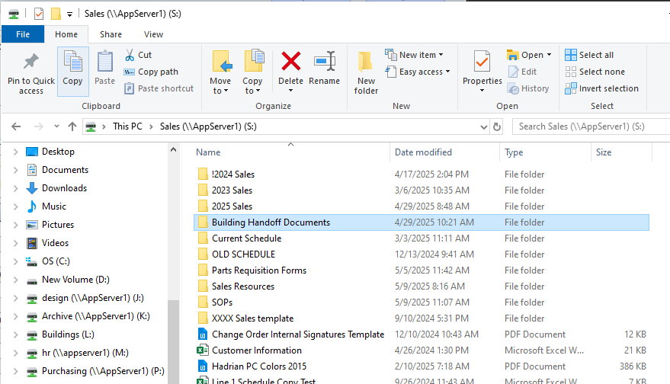

- Copy and paste the handoff documents into the PC Handoff sub-folder of the Bid folder.
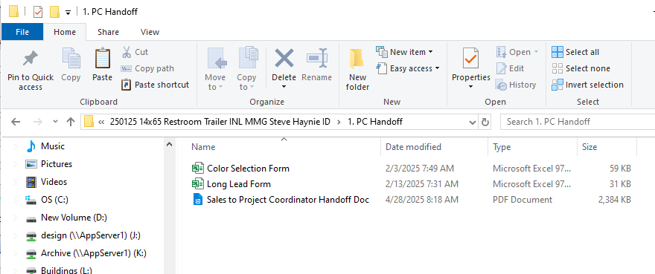
- Rename the handoff documents to include the building serial number(s) at the beginning of the document title.
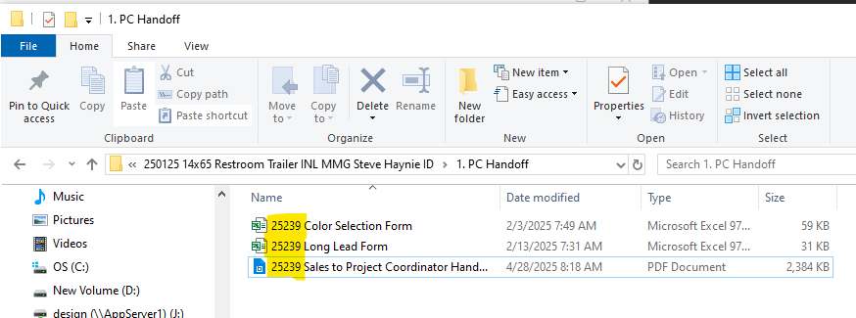
- Open the Color Selection Form and add an X to any items that will receive a color selection. Note brands for the Project Coordinator where applicable.
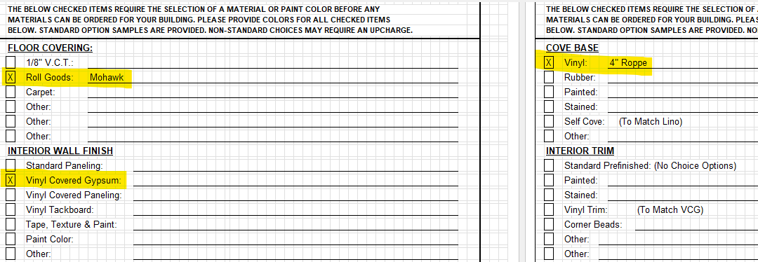
- Open the Long Lead Form and add long lead items and expected lead times. If there are any items that have a longer lead time than state submittals take, be sure to let the Project Coordinator know in your handoff email so we can get them signed off on before customer approval of the drawings.
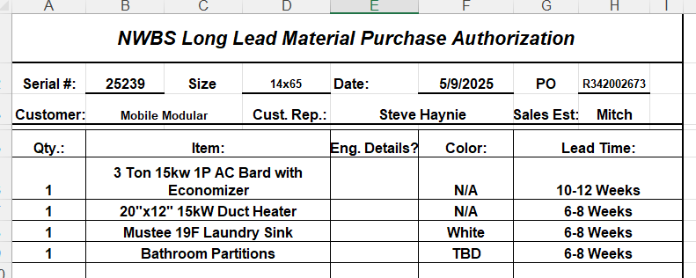
- Now fill out the Project Coordinator Handoff Document basic information.
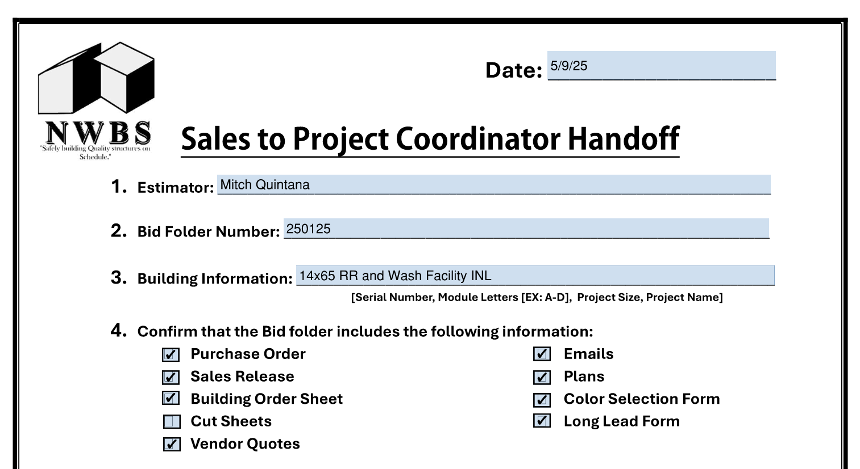

- Then fill out the added services the customer requested. You should know in the bidding stage if any of the following is required:
  - Cut Sheets
  - Physical Samples
  - O&M Manuals
  - Foundation Plans
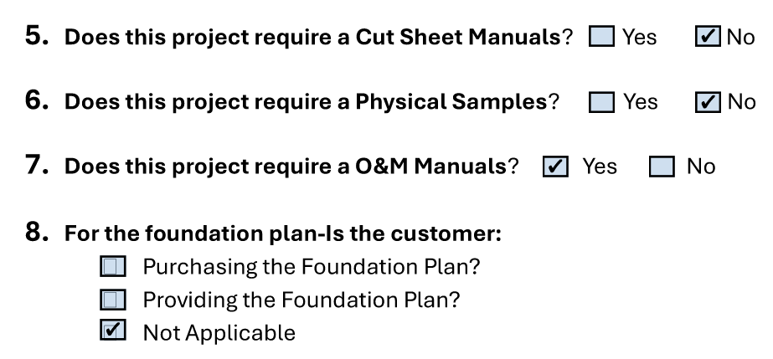
- Lastly for the Sales to Project Coordinator Handoff document, fill out the miscellaneous information. Be sure to include the material cost, mechanical cost, and quantity of plumbing drops for the project coordinator’s state submittals.
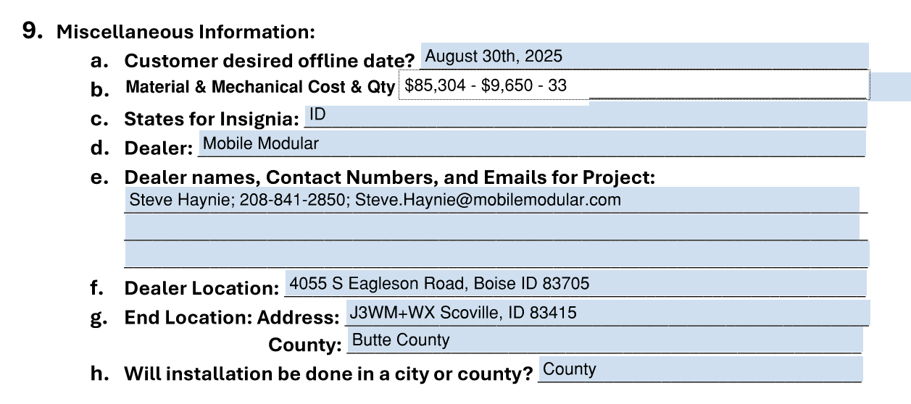
- Save the Sales to Project Coordinator Handoff document when done.

- Moving to your email, attach the handoff document, color selection form, long lead form, and PO/NTP. Email the PC, GM, Design Manager, Production Manager, Purchasing Manager, and Accounts Receivable. Include any difficulties you foresee with the building including materials, manufacturing methods, lead times, expected offline dates, etc.

Let the GM know approximate offline date so he knows what was promised to the customer.

- DONE!!

